STOCKVEL TEST NOTES

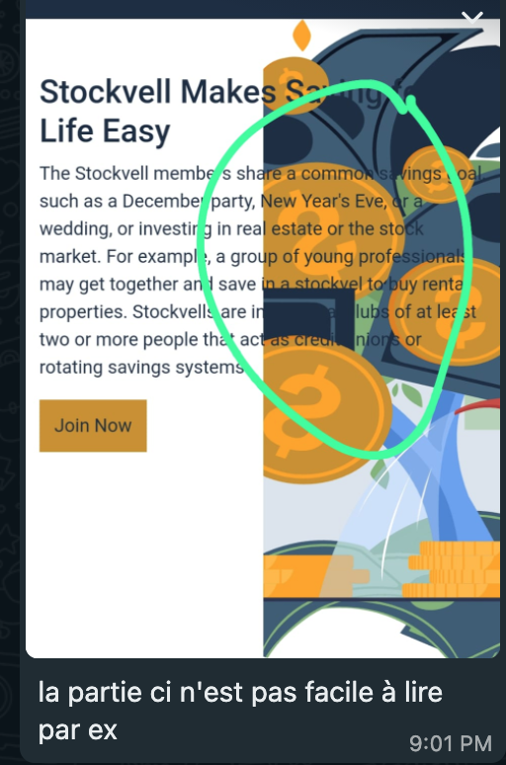

This is the rendering on phone of the home page

1- HOME PAGE

- Write STOCKVEL, not STOCKVELL
- Can we just have English or Francais, without “Lang” appearing?
- 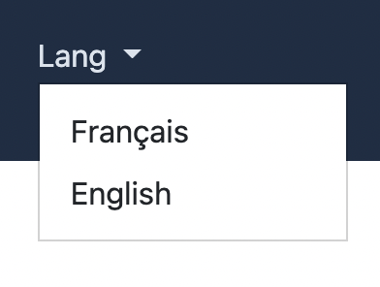
- We need to work more on the text translation and quality. It does not change from english to french.
- 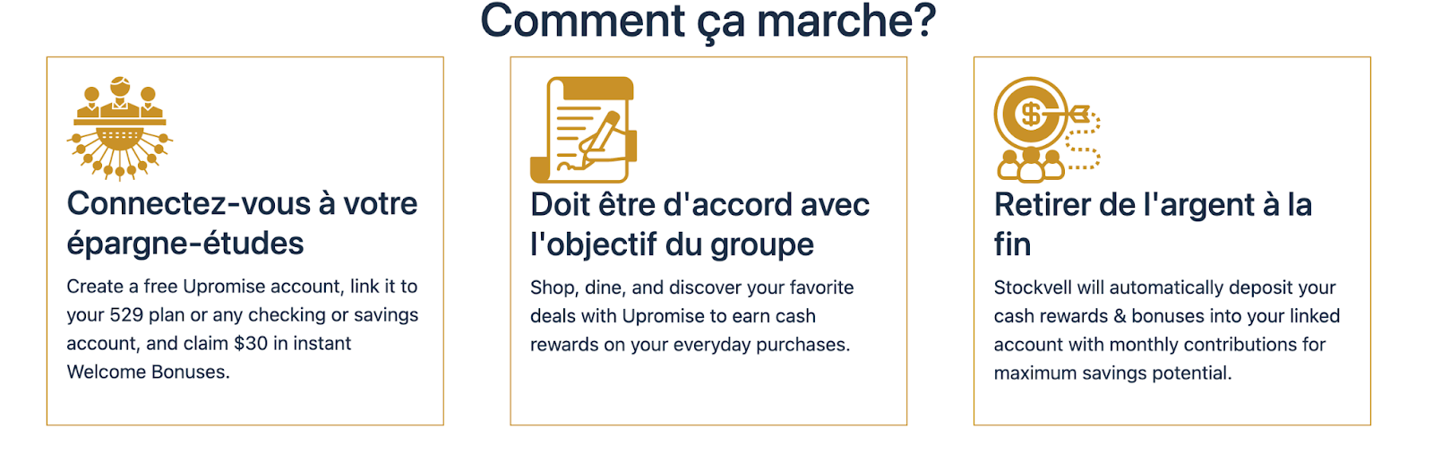
- I don’t know what this stands for, but it does not look good
- 
- We need to work on the font and quality of the text. It does not look good or friendly to read
- 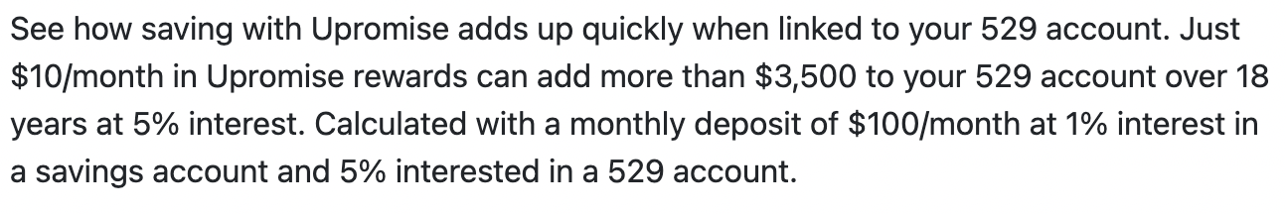
- Can all digital illustrations be black people?
- 
- Stockvell Makes Saving for Life Easy Stockvel makes saving and investing easy
2- SIGN UP/SIGN IN PAGE
- In general, when a user is signing up, there is no need of Gov ID. It’s only required when the person wants to create a pack to become a member or pack leader.

- I had signed up with my email but when signing I receive this:
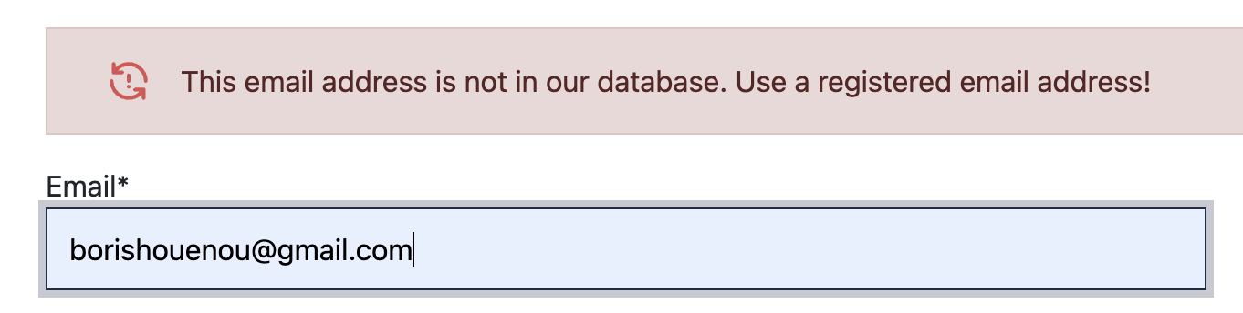

- Should be “ My password is incorrect or the information provided does not match our records, or ….”
-

- Login using phone : “+” shows up but without the country code which I believe is what you want to have here. 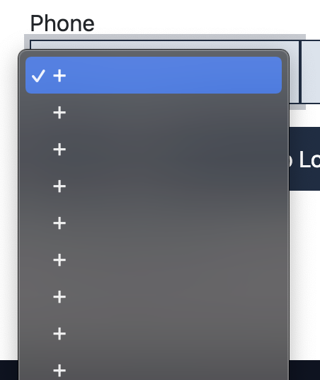

- Country list does not have the “United States” and it seems to me that not all countries are here. Please check 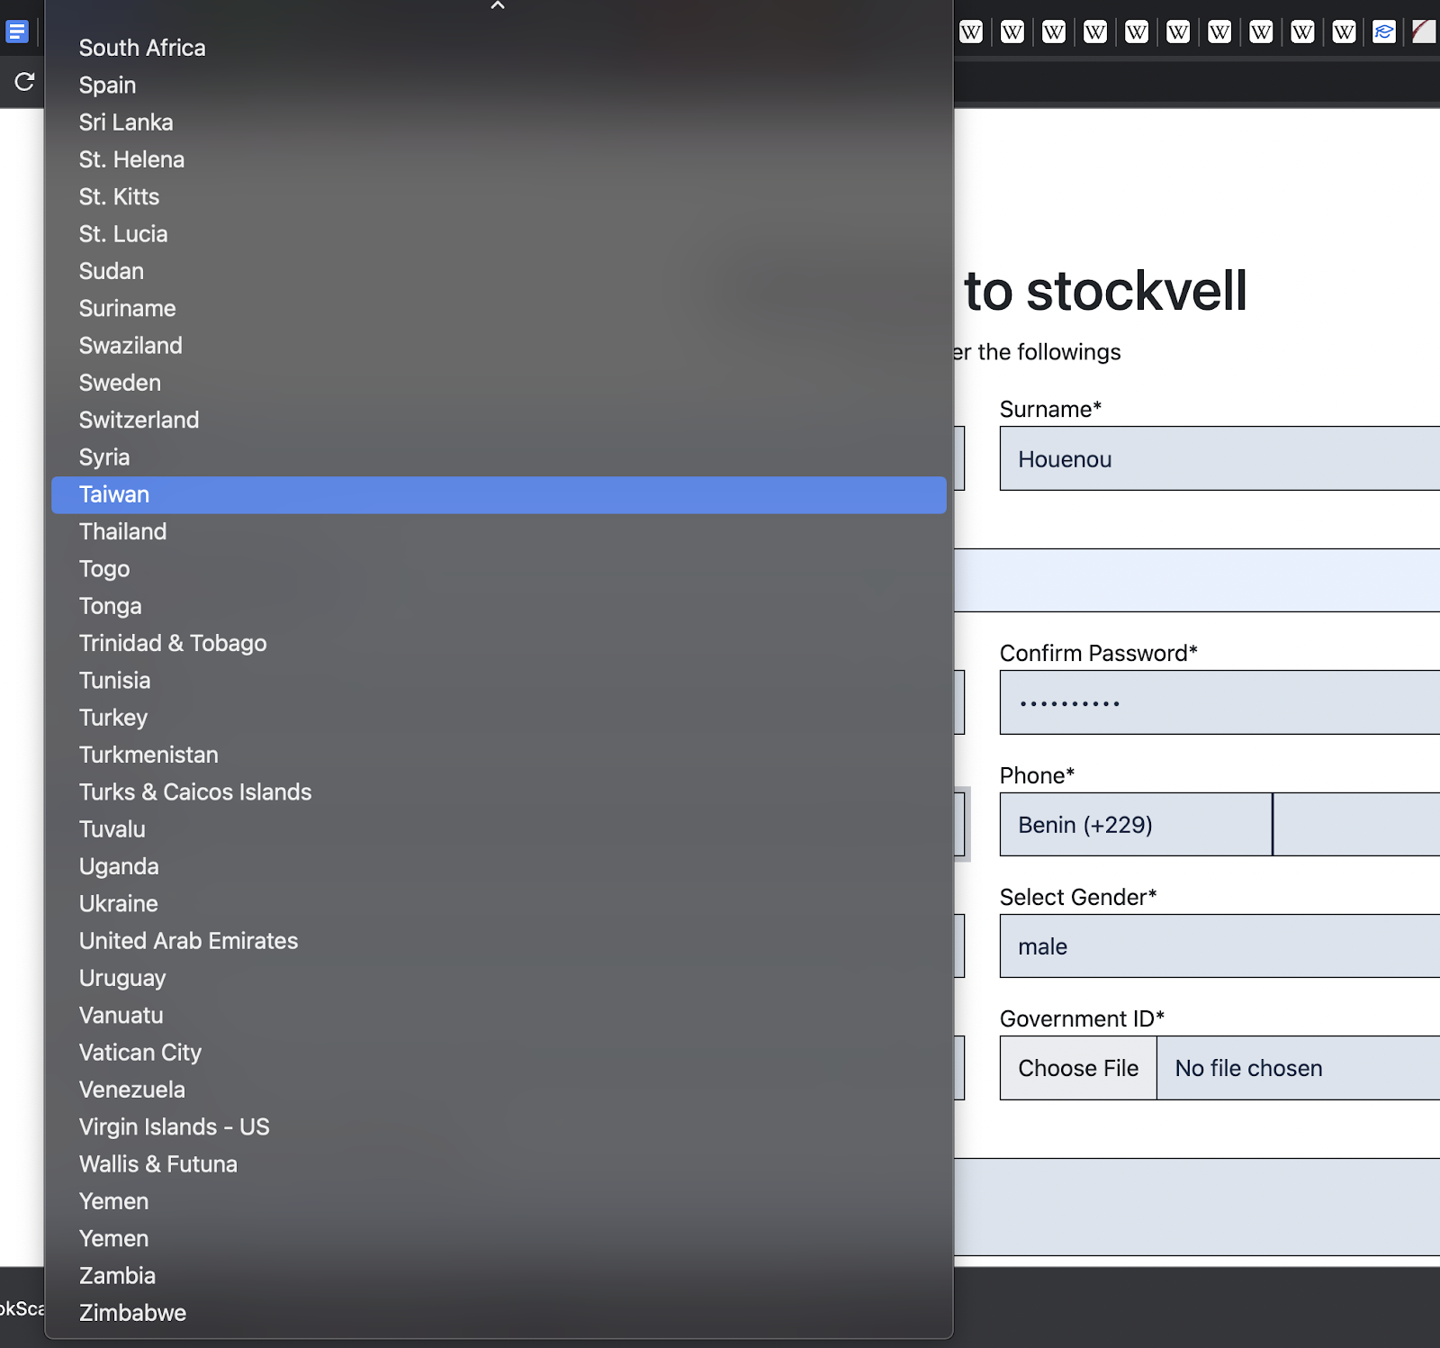

- I think the same for profession list: either the list is broad or we use categories instead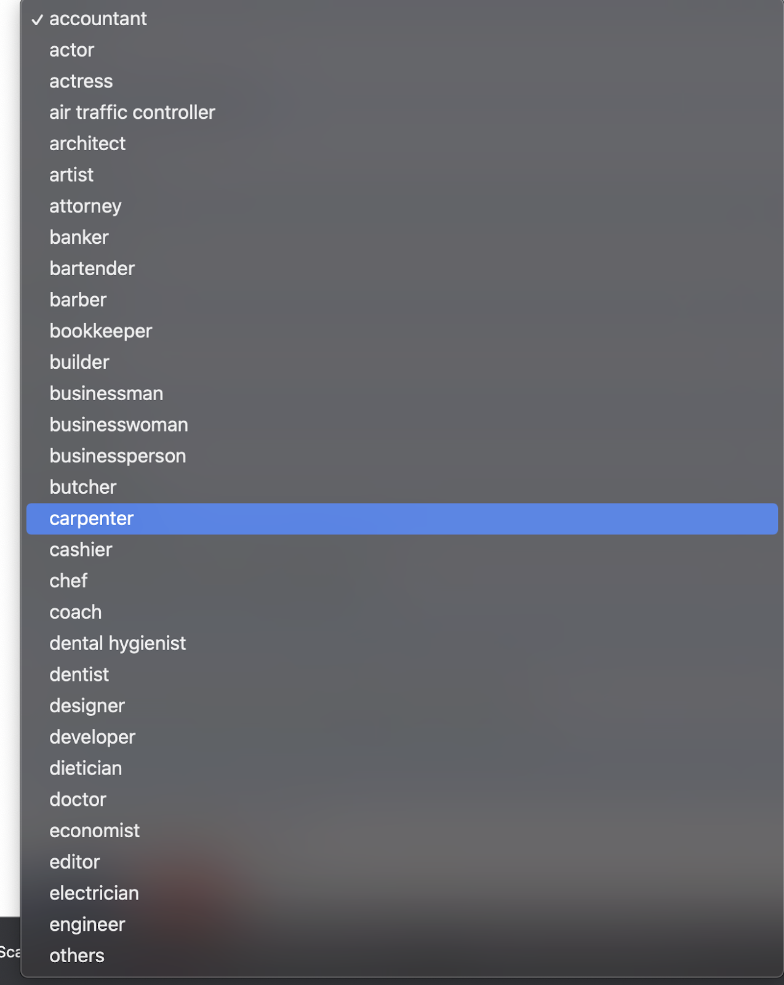

- When you forget to check the “privacy policy” box, you lose some information you have filled before. That is not time efficient, unless there is a security reason to it. Can we keep the information instead? You can see I lose first name, surname, email, password, confirm password, city, phone, gov ID but profession, gender are saved.
- 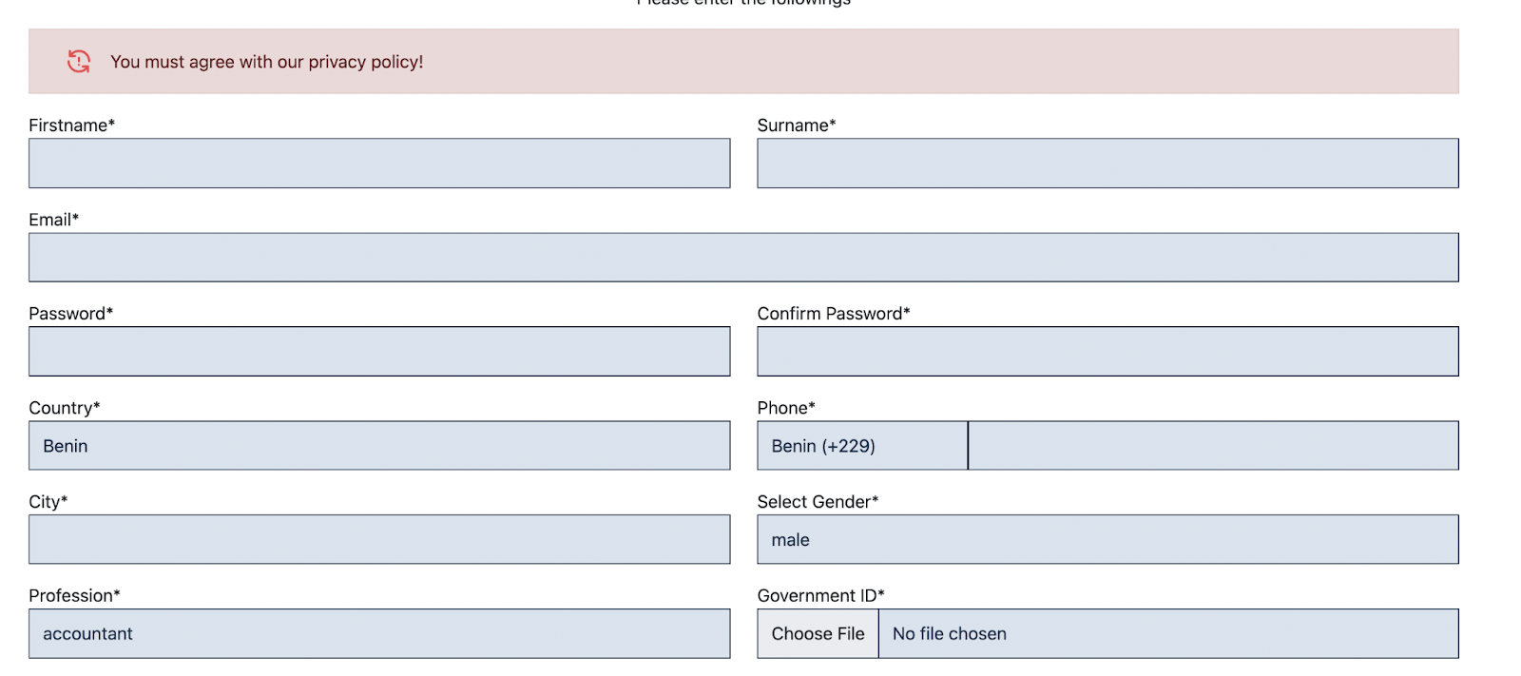

- Now I create my account, but do not have any notification in my email. How about when I use a phone? Do I get a text?

3- ONCE YOU SIGN IN

Profile

Update your informations!

Update your information!

My packs:

All of my pack!
My packs
All the pack that you are a member of.

All the packs that you are a member of.

Pending pack:

All pending packs!

You can find all the stockvell pack that is made and requested for approvals. N.B. If you can not find a pack that you have created, in that case, the pack is been rejected. Try creating another one with proper informations!

Pending packs
You can find all the stockvel packs that are made or requested for approval. If you cannot find a pack that you have created, the pack has been rejected. Try creating another one with proper information!
Closed Packs

All close packs!
You can find all the stockvell pack that is close and requested for closing. N.B. If you can not find a pack that you have created, in that case, the pack is been rejected. Try creating another one with proper informations!

Closed Packs!
You can find all the stockvel packs that are closed or requested for closing. If you cannot find a pack that you have created, the pack has been rejected. Try creating another one with proper information!

Create a pack

Create your own Stockvell pack!
You can create your own stockvell, in order to do that you need to fill in all the input fields and once you create your will request of creating a new pack will be under our review.

Create your own pack!
You can create your own pack. In order to do that you need to fill in all the input fields. A new pack needs to be reviewed.

- 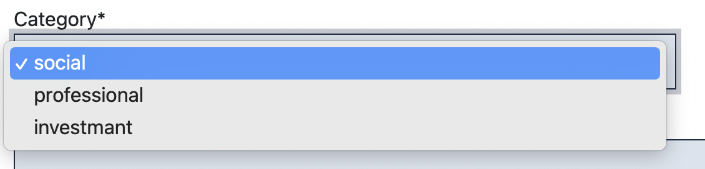
- Category (social, equipment acquisition, investment, commercial)
- To create the pack, in category, write investment instead of investmant

- Can we have a boilerplate for a template contract : 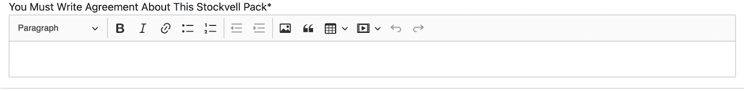

- You need to submit all proof because once you create a stockvell pack by default you will request to be the leader of the group. We will check your papers, if everything is okay we will accept your pack!
- You need to submit all proof because once you create a stockvel pack by default you will request to be the leader of the group. We will check your papers, if everything is okay we will accept your pack!

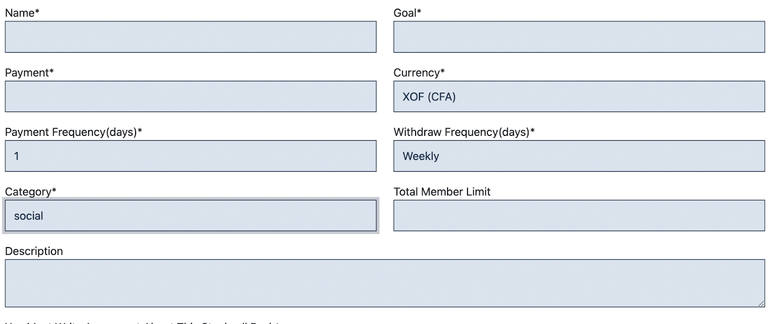
- Payment Frequency(days) Payment Frequency (days)
- Withdraw Frequency(days) Withdrawal Frequency
- Add start and end dates as parameters

- It might be better to keep the payment and withdrawal frequency the same, the same format.
- Can we remove “Goal” because I believe it’s conflicting with “Category”
- Can we have tooltips for each block in the create pack? So that they serve as guides to people who want to create? For instance, having a suggestion of what a “description” looks like is helpful.
- I was wondering if the Gov ID does not have the address and then serves as proof of address
- Address Proof (JPG, PNG, PDF)
- Proof of address (JPG, PNG, PDF)
- After successfully created a pack, it does not appear in my “pack”. I suggest, it appears there, but not active until it is approved and removed from “pending packs”

4- MISSING
- Once you input all information to create pack, ask to review in a review page and then submit to create
- Once you created your pack, get an email, text or phone notification with a link to the pack
- The pack leader should be able to invite people to his pack and send them the link to join the pack (sign up, sign in) based on the invite. The invitees could parent or people in his networks or contacts. How to connect to phone/email contacts?
- Make the link to the pack shareable through WhatsApp, social media, phone
- The leader of a pack should also be able once a pack is approved to admit see members who want to join his pack and allow them in up to the total members limit it was set when the pack was created.
- Each pack must have a simple balance sheet tool and scheduling tool for meeting between the pack leader and members (Calendly, when2meet, etc…)
- Each pack leader should have access to payment tool (mobile money, bank, card, etc..)

NB: I have not checked the admin page yet. To follow.

